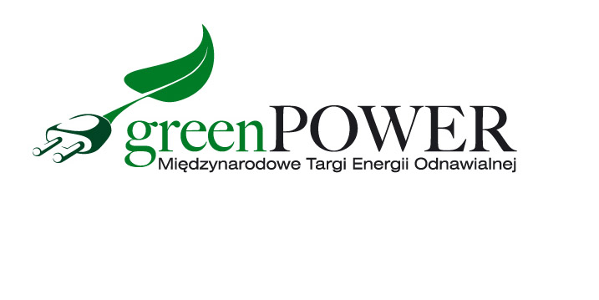

**Press Release Poznań, 14.07.2021 r.**

**The renewable energy sector exhibition in September in Poznań**

**Are you looking for green energy solutions? Visit the Greenpower fair and learn about the latest solutions and the current offer of the RES market.**

The Greenpower International Renewable Energy Fair is a great opportunity to meet specialists in the renewable energy sector. This year, the fair will be held on September 14-16 at the Poznań International Fair.

During the event, modern products and services in the field of photovoltaics, biogas, biomass, wind, water and geothermal energy, as well as biofuels are presented. The presentation of charging infrastructure and electric vehicles is also noteworthy.

- Excessive exploitation of natural resources not only results in consequences in the global imbalance of the environment, but more and more often reduces the standard of living of individual entities. Ecological trends are no longer a topic dedicated only to talks at the summit. They take their place in the neighborhood of local business and even in our homes. Their epicenter will be at the Poznań International Fair during Greenpower - notes Marcin Gorynia, director of the Greenpower fair.

Of all the sectors, the photovoltaic industry is developing the most dynamically. The decline in the prices of photovoltaic panels in the last decade has made photovoltaics one of the cheapest technologies for producing electricity today. It is at the Greenpower fair that you will be able to see the latest photovoltaic solutions for home, business and, for example, farms. Mounting systems, photovoltaic modules, inverters, optimizers, energy storage, inverters, converters are some of them. Industry representatives will also help in the selection and profitability analysis of PV systems.

The business structure of the participants clearly translates into new investor relations. Investors, developers, installers, as well as system designers participate in the fair. The event has become a permanent fixture in the calendar of representatives of local government authorities, owners of hotels, holiday resorts, hospitals, farms, and managers of public buildings.

Free invitations to the Greenpower fair are available on the website [www.greenpower.mtp.pl](http://www.greenpower.mtp.pl)