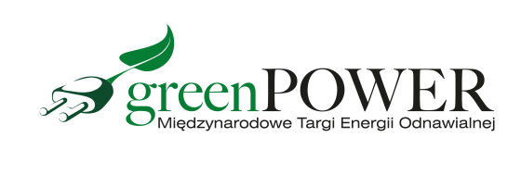

Press Release Poznań, 16.09.2021 r.

GRENPOWER - positive energy at the fair

Energy from renewable sources is very popular, but in order to reduce electricity bills it must be well installed. What solutions to choose, what to pay attention to when choosing panels? These questions were answered by the exhibitors of the GREENPOWER fair for three days.

Over 80 exhibitors advised which solution to choose and what to do to make it the most profitable. The visitors to the fair received information about subsidies and programs related to the use of renewable energy sources.

During the event, modern products and services in the field of photovoltaics and oze were presented. The following items were presented: ground and roof mounting systems, various types of PV modules, inverters, optimizers and energy storage. Experts and experts advised which panel display would bring the greatest benefits and how to protect it against fires.

Latest knowledge
- Many people come to Poznań to the fair in search of the latest knowledge. During GREENPOWER, industry meetings, presentations of new products or conferences are held - notes Marcin Gorynia, director of the Greenpower fair. During the event, you could take part in the Globenergia Energy Talk Show, training sessions organized by Emiternet and the conference "Self-sufficient municipal energy cluster" organized by the Polish Climate Forum.

Awarded with medals
Six innovative products were awarded with MTP Golden Dedals. The Mono VI photovoltaic module from Soluxtec - the first module using cells with a power above 380 Wp, deserves this unique distinction. The N-TYPE panels by Jolywood also deserve a distinction, as they are manufactured according to the innovative N-type technology. The Gold Medal was awarded to the Perfect Edge PEM.G0-390W photovoltaic module by Bruk-Bet Sp. z o. o. consisting of 120 monocrystalline cells made in the Half-Cut technology. RECOM SERIES PUMA Econstructions Group Spółka z o.o. - single and double-sided as well as low-emission - have also been awarded this unique distinction.
Along with the growing interest in photovoltaic panels, the interest in services related to the operation of panels is increasing. One of the modern market solutions is undoubtedly the QLEEN Disy Full Version washing device by LEWI-POLSKA with a wide range of applications. A positive assessment and recognition of the Competition Jury was also given to the innovative Austa inverter by PV Energia Polska - a three-phase inverter, characterized by high efficiency reaching 98.7%.

Market news
Two exhibitors presented their latest products. As many as three new products could be seen at the Wolna Energia stand. These were: Blue boson - a new water treatment structure, a heat pump and a battery that will work perfectly both in emergency mode and in off-grid installations.
On the other hand, the ECCOSOL company presented SOLAR MULTIBOARD that enables the installation of photovoltaic panels without damage.

We invite you to the next edition of the GREENPOWER fair, which will be held simultaneously with the International Installation Fair Installations on April 25-27, 2022.

www.greenpower.mtp.pl

