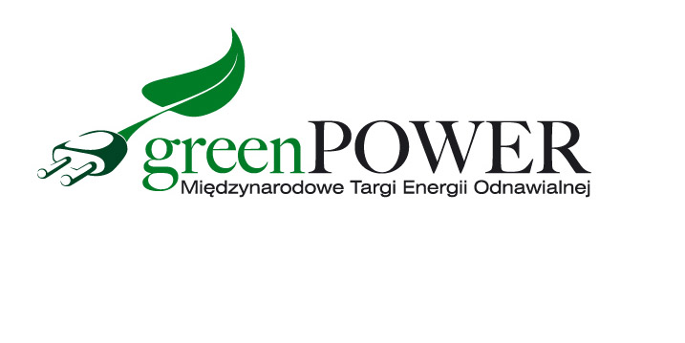
Press release Poznań, April 27, 2022

Nearly 300 exhibitors presented the latest products and technologies in the field of renewable energy, as well as techniques during the Greenpower and Installations fairs. It was three days filled with talks, meetings and positive energy!

The exhibitors of the GREENPOWER fair and the INSTALACJE fair held at the same time presented, on an area of ​​25,000 m2, the offer of leading manufacturers and suppliers of equipment, technologies and services in the field of renewable energy sources as well as heating, air-conditioning, ventilation and cooling technology.
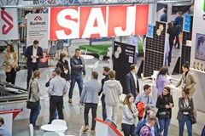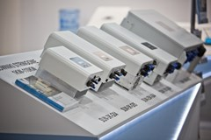
- Both events were visited by people who design, build and install intelligent and modern energy-saving systems, both in the public and private sectors. This is the largest block of fairs devoted to oze and heating technology this year in Poland - emphasizes Marcin Gorynia, director of the GREENPOWER fair.
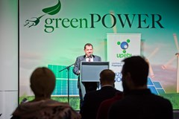
The exhibition offer was enriched by conferences and trainings accompanying the GREENPOWER fair. The topics discussed during these meetings concerned the most current topics in the renewable energy sector - from netbilling, changes in the Clean Air program, sources of financing biomethane investments to building the value of companies in the oze industry, ending with training in the audit of photovoltaic installations.
• Building goodwill in the renewable energy industry, or how to reduce costs and increase revenues
Organizer: Relationship Marketing
• How to support the green transformation of companies?
Organizer: Lewiatan Confederation
• Energetic Talk Show Globenergia
Organizer: Editors of Globenergia magazine
• Biomethane briefing
Organizer: Union of Producers and Employers of the Biogas Industry
• Audit of the photovoltaic installation
Organizer: Atumedu.pl
• Elements of the agricultural RES cluster

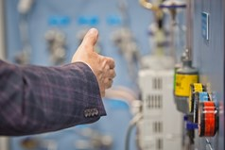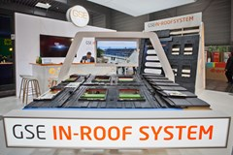

The GREENPOWER fair was a great place to present new products. It is mainly for them that visitors to the fair travel hundreds of kilometers to see the innovative solutions used in the industry up close and learn about the latest offers of exhibitors. Many companies took advantage of this opportunity, including: MP Solar Group, which presented container energy storage systems for industry during the fair. Another novelty were GSE underroof systems for attaching photovoltaic panels to the roof. This system allows the panels to be integrated directly into the roof and is therefore installed in place of the tiles, offering an economical solution. The Agro-Rydz company presented a washing system for large-area photovoltaic farms.

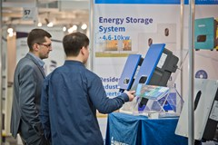
The most innovative products have been awarded the Gold Medal of the MTP Group. Almost 500 products enter the competition for the Gold Medal of the MTP Group each year. However, only those that meet the statutory criteria and receive positive recommendations from a professional jury receive this prestigious award. This year, the Gold Medal of the MTP Group at the GREENPOWER fair was awarded to:
• SOLA HybridMaster 200 hybrid heat pump - combines the operation of a traditional pump supported by a gas condensing module, thanks to which your bills will be significantly reduced. AFORE POLSKA Sp. z o.o.

• ATES containerized energy storage systems for industry - they also protect against unbalanced parameters on the network, which pose a risk of damage to expensive machines. Atess / MP Solar Group Sp. z o.o.

• JOLYWOOD TOPCon 2.0 - bifacial modules in the NTOPCon 2.0 cell technology with very high efficiency, very low cell degradation and a very low temperature coefficient. JOLYWOOD (TAIZHOU) SOLAR TECHNOLOGY CO., LTD. ECONSTRUCTIONS GROUP Sp. z o.o.

• HEGATECH - silicon wafers and cells for modules, which guarantees the manufacturer's independence from other entities, and thus eliminates the problem of production and delivery stagnation. HEGATECH / ECONSTRUCTIONS GROUP Sp. z o.o.
The winner of the Consumer Choice competition was the product - Container energy storage systems for the ATES industry, submitted by MP Solar Group Sp. z o.o.

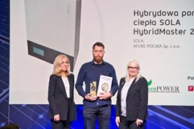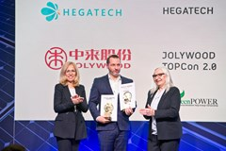

We invite you to the next edition of the GREENPOWER fair!
May 10-12, 2023

Detailed information - www.greenpower.mtp.pl

