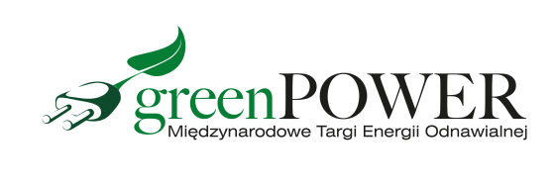

Press Release Poznań, 30.08.2021 r.

How to reduce electricity bills? Experts at Greenpower will say

Photovoltaics is very popular, but to reduce electricity bills it must be well installed. How to do it, where to get funding, what solutions to choose? Greenpower exhibitors will answer these questions.

The Greenpower International Renewable Energy Fair is a great opportunity to meet specialists in the renewable energy sector. This year, the fair will be held on September 14-16 at the Poznań International Fair.

During the event, modern products and services in the field of photovoltaics and oze will be presented. The exhibition will include: ground and roof mounting systems, various types of PV modules, inverters, optimizers and energy storage. Experts and professionals will advise you which panel display will bring the greatest benefits and how to protect it against fires. Visitors to Greenpower will receive information on funding opportunities. Industry representatives will also help in the selection and profitability analysis of PV systems.

- A photovoltaic installation can lower your electricity bill if it is well sized and installed. For many people who have decided on such an investment, the advantage is that they obtain renewable energy in an ecological way, thus contributing to environmental protection. An additional advantage is the increase in the value of the property - notes Marcin Gorynia, director of the Greenpower fair.

Of all the sectors, the photovoltaic industry is developing the most dynamically. The decline in the prices of photovoltaic panels in the last decade has made photovoltaics one of the cheapest technologies for producing electricity today. It is at the Greenpower fair that you will be able to see the latest photovoltaic solutions for home, business and, for example, farms.

Free invitations to the Greenpower fair are available on the website www.greenpower.mtp.pl

