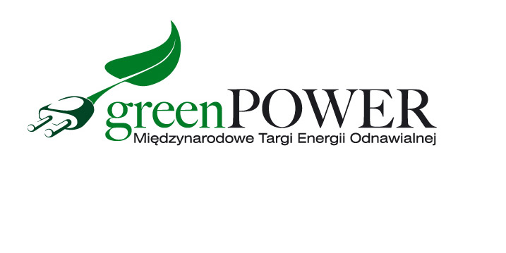
Press release Poznań, April 11, 2022

Innovative solutions in the field of photovoltaics and heating technology at the GREENPOWER fair

The European photovoltaic industry recorded the best result in 2021
in history. Investments in Poland largely contributed to this. Energy-saving systems are not losing their popularity. A rich exhibition offer in the field of photovoltaics and heating technology will be available in April during the GREENPOWER fair in Poznań.

In 2021, photovoltaic power plants with a capacity of 25.9 GW were put into operation in the European Union. This is a spectacular success for the PV industry. Poland, with 3.2 GW of new capacity, was the fourth largest investment market in the EU. The development of the photovoltaic industry was certainly influenced by the prosumer support system, the drop in panel prices, as well as the increased environmental awareness. Poles are more and more willing to look for energy-saving solutions.
The latest photovoltaic technologies for home and business will be on display at the GREENPOWER fair. Mounting systems, photovoltaic modules, inverters, optimizers, energy storage, inverters, converters are some of them. Industry representatives will also help in the selection and profitability analysis of PV systems.

The fair creates not only rich exhibition expositions, but also numerous conferences, debates and trainings. The accompanying GREENPOWER program is built on the knowledge of experienced industry experts.

The business structure of the participants clearly translates into new investor relations. The fair is attended by investors, developers, installers, as well as system designers. The event has become a permanent element of the calendar of representatives of local government authorities, owners of hotels, holiday resorts, hospitals, farms, as well as managers of public buildings.

- This year, the GREENPOWER fair will be held together with the INSTALACJE fair. The events are aimed at people who design, build and install intelligent and modern energy-saving systems, both in the public and private sectors. This is the largest block of fairs devoted to oze and heating technology this year in Poland - emphasizes Marcin Gorynia, director of the GREENPOWER fair.

The GREENPOWER International Renewable Energy Fair
25-27.04.2022, Poznań

At the same time, the following will take place:
INSTALACJE International Fair of Installations and Equipment
SECUREX International Security Fair
EXPOPOWER International Power Industry Fair
The SAWO International Fair of Labor Protection, Fire-Fighting and Rescue

Detailed information - www.greenpower.mtp.pl

